ACTIVITY 16: postgreSQL

STUDENT’S NAME: Tamzimul Alam

a) INSERT INTO artist(id, name)

VALUES(3,'Tamzimul Alam');

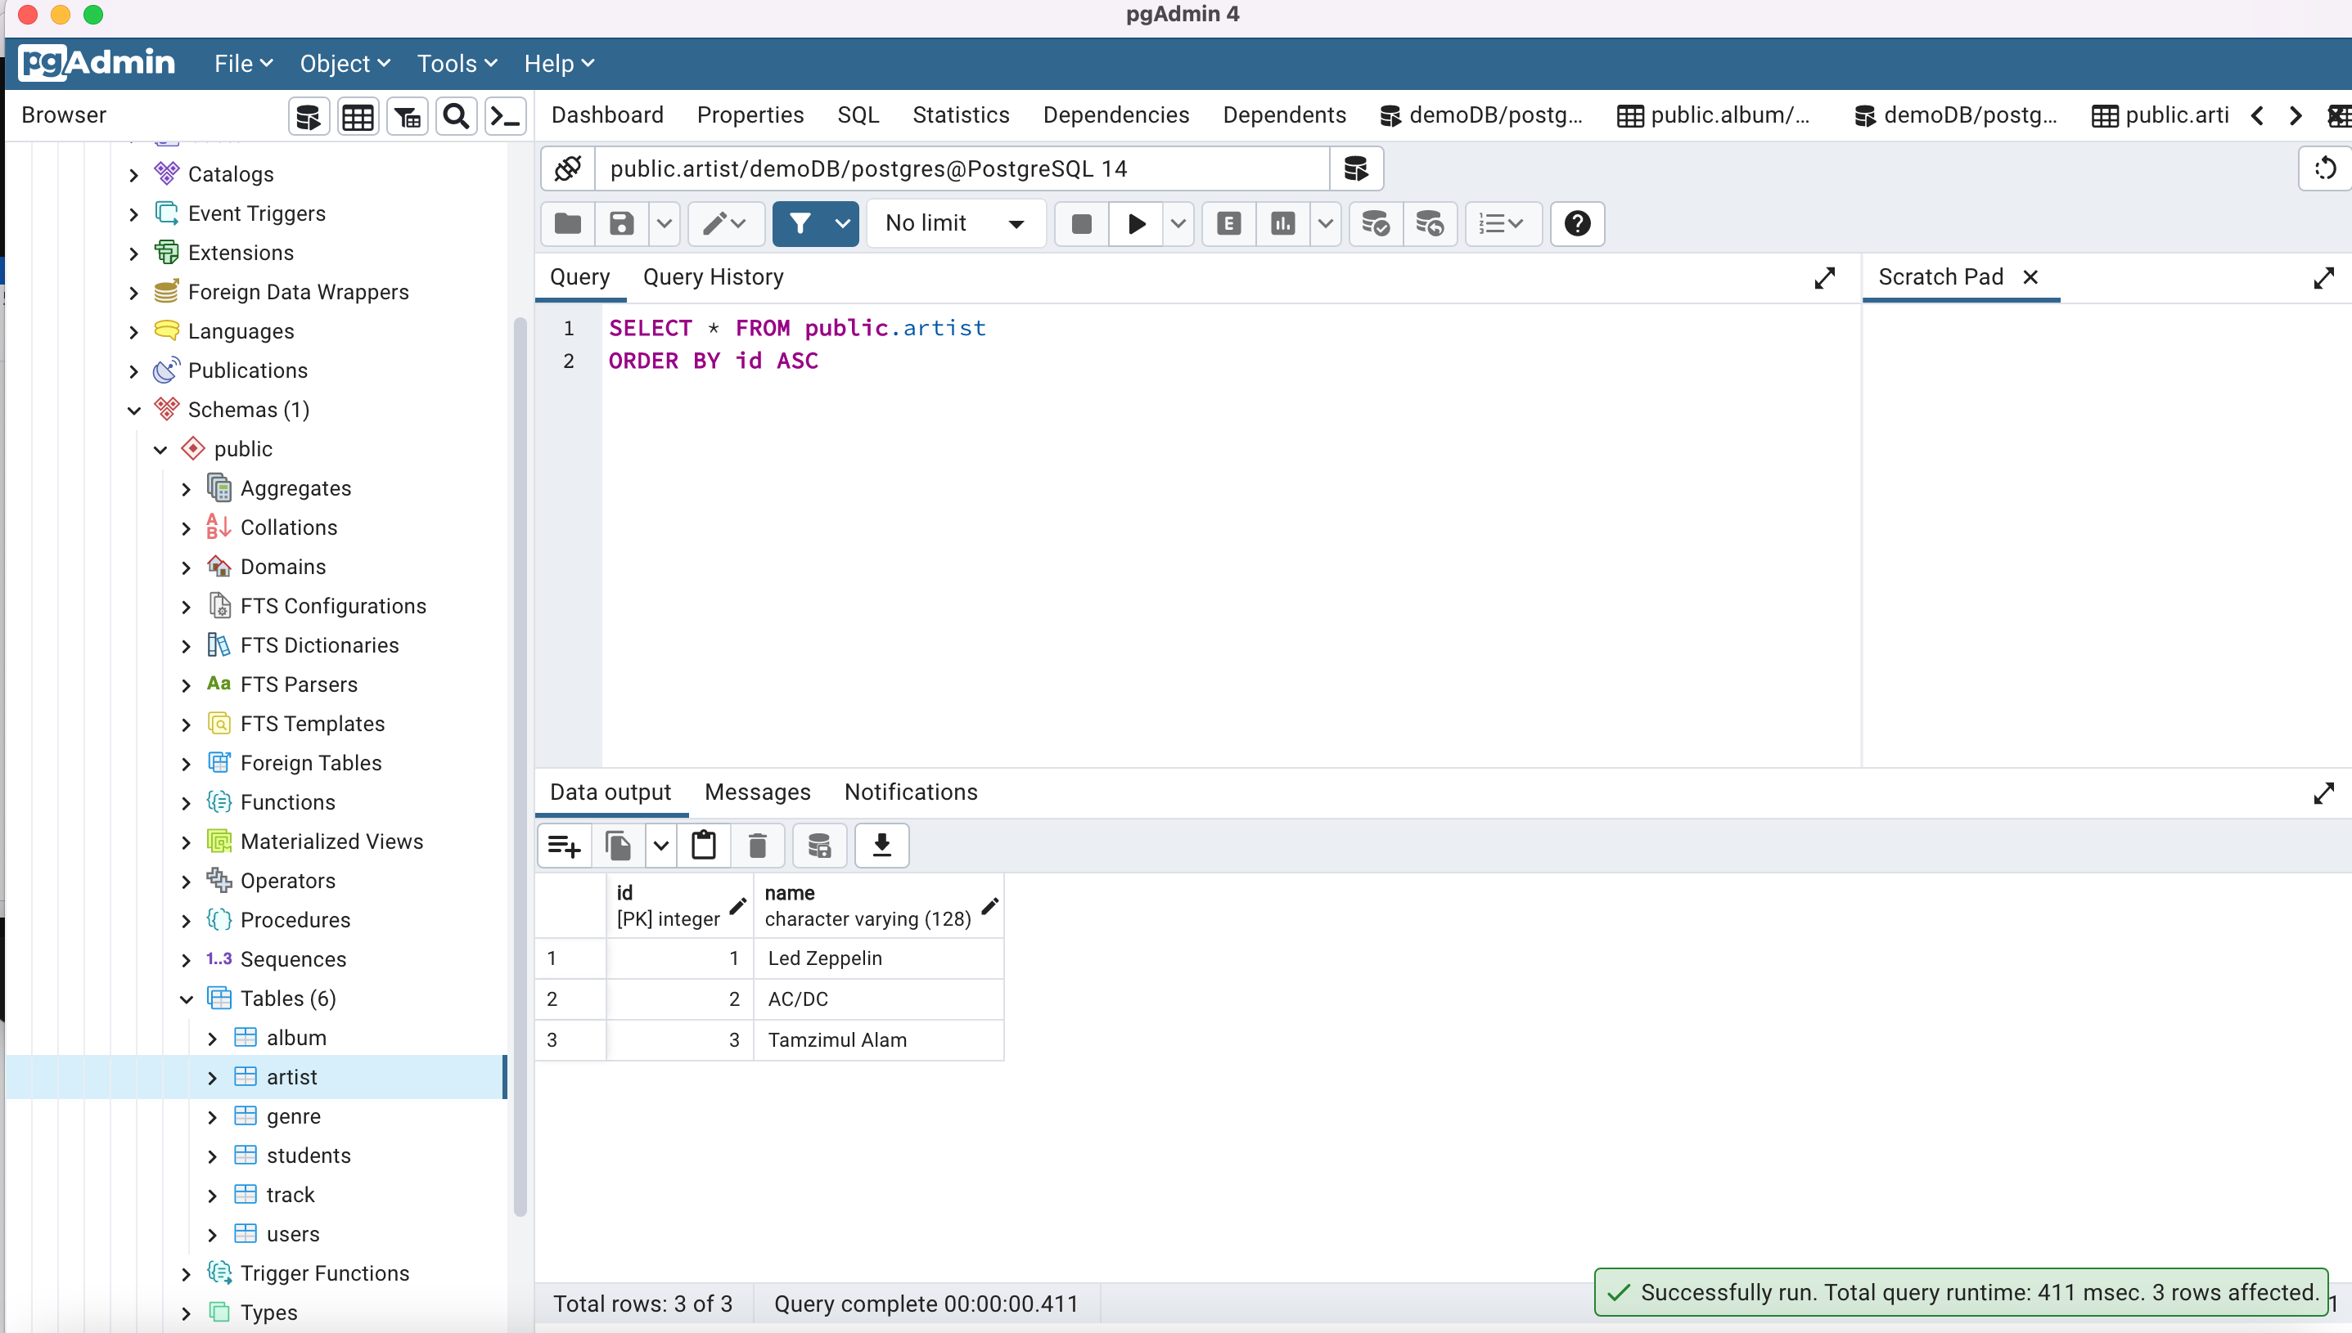

b) INSERT INTO album(id,title,artist_id)

VALUES (3,'LOVE IS GONE',3);

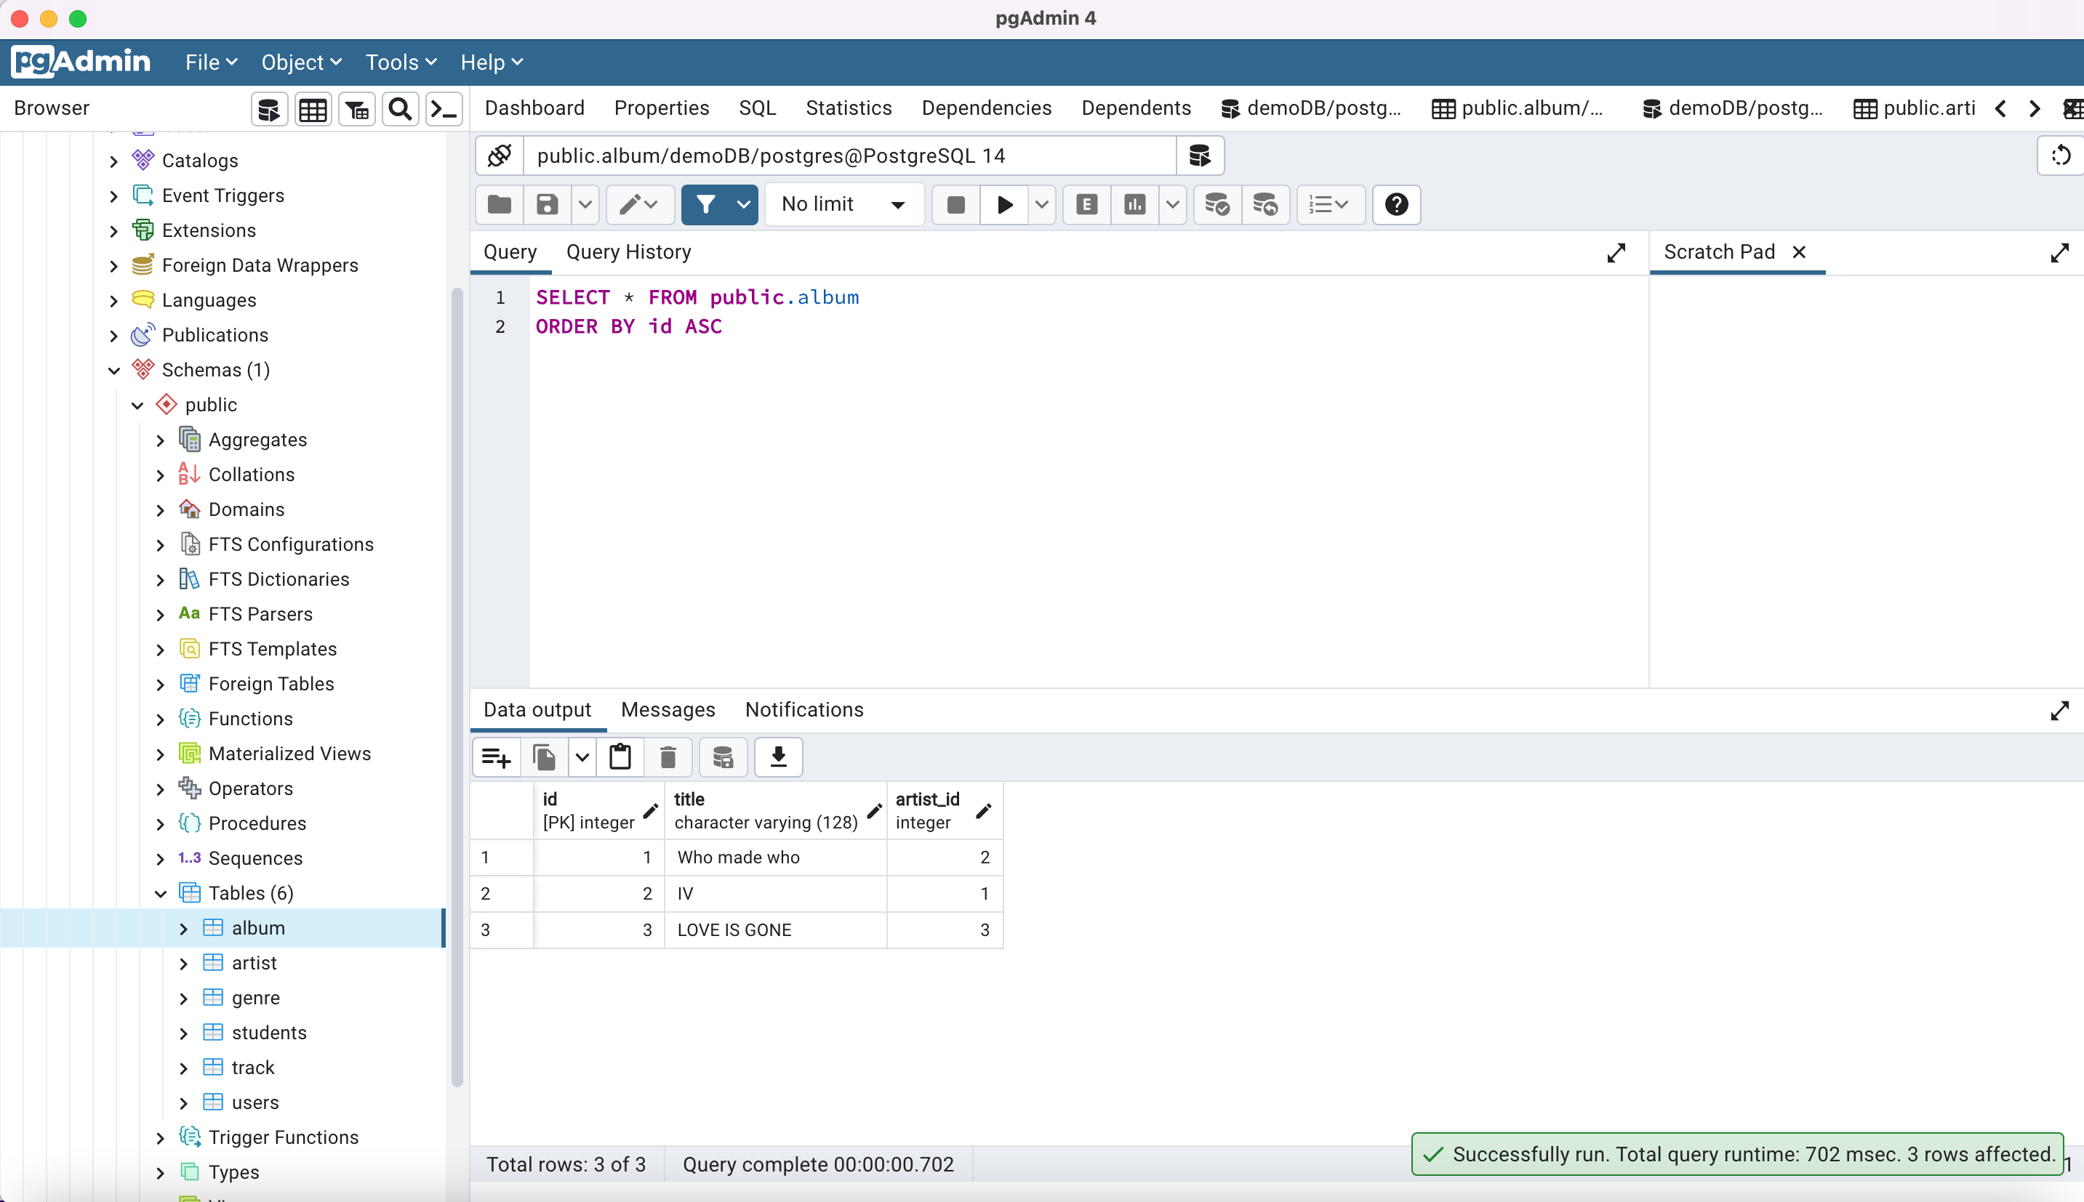

c) SELECT album.title, artist.name, artist.id FROM album JOIN artist ON album.artist_id = artist.id;

d)